**Session report 28/02/2023:**

*LABAUVIE – RAFFAELLI EVA*

*ROB3*

For today’s session, I decided to explore a new track.

During the IA festival at Cannes, I met a programmer who had made a code to recognize different types of trash with IA. We discussed a moment and he told me he used YOLO to program his IA, and suggested me to try it since it works well.

So I’m trying to use it from the start, following this tutorial :

<https://neptune.ai/blog/object-detection-with-yolo-hands-on-tutorial>

* To begin I downloaded Git Bash on my computer.
* Next I made a folder, right clicking on it an clicking on “Git Bash here”
* In this folder I cloned a repository that the tutorial suggested

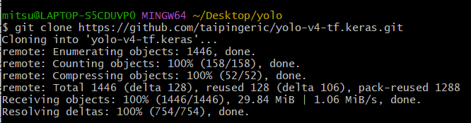

* Next I downloaded the model weights (parameters needed) from the suggested GitHub.

To do so, they are some prequisites :

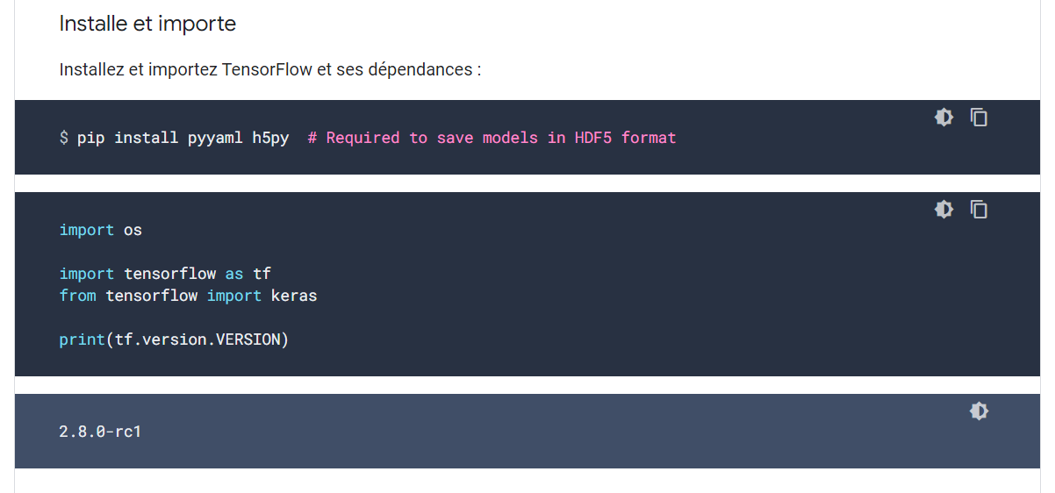

I also created a virtual environment to host the future modelling :



And activated it



At the same time I printed the bucket with Xavier at the fablab but I didn’t made is attach the right dimensions, it doesn’t fit the wheel so I will have to print them again.

